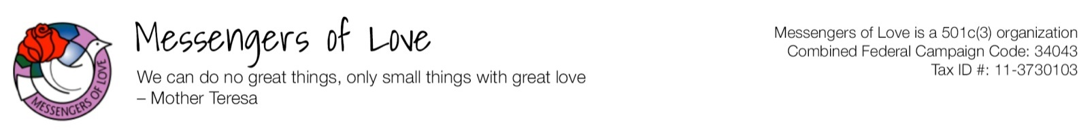
Airline Ticket Grant Application
(Application deadline is May 30, 2020)

This grant is for airline ticket assistance for travel to Vietnam to participate in the English Teaching and Cultural Exchange program as a volunteer teacher. The amount granted will be half of the price of the ticket up to a maximum of $500. Volunteers are responsible for fundraising for the remaining amount.

1) Please fill in all fields and email this form to executive.director@messengersoflove.com.
2) Please scan proof of income (most recent tax return or pay stubs) for yourself and/or your parents if they are responsible for your expenses and include it with this application.

Name: | Click here to enter text. | Email: | Click here to enter text.
Occupation: | Click here to enter text. | Phone: | Click here to enter text.
Address: | Click here to enter text. | City, State, Zip: |  | Click here to enter text.

Do you work full-time, part-time, or are you retired? ☐Full-time ☐Part-time ☐Retired
Click here to enter text.

What is your household annual income?

Are you currently enrolled in an educational institution? ☐Yes ☐No
If yes, are your parents responsible for your expenses? ☐Yes ☐No
Click here to enter text.

If yes, what is your parent’s combined annual income?

If you are a full-time student and your parents are responsible for your finances, may we contact a parent if we have any questions? ☐Yes ☐No

Parent’s Contact Information

Name: | Click here to enter text. | Email: | Click here to enter text.

Phone: | Click here to enter text.

I verify that all statements in this application are true to the best of my knowledge.
Signature: | Click here to enter text. | Date: | Click here to enter text.

